|  |
| --- |
| The Caribbean Coral Skeleton Identification Guide (CCSIG) |
| Bee Ling Melisa Chan, Nicte-Ha Muñoz, Mauro Lepore |

*Tip: Print on both sides of the paper, starting with this page on the front side of the paper to keep the images and tables of corals side by side.*

# Read Me

1. The Caribbean Coral Skeleton Identification Guide (CCSIG) is an identification guide that is based on the physical characteristics of coral skeletons.
2. The CCSIG currently (as of August 31, 2016) contains most of the species that can be found in Bocas del Toro, Panama.
   1. Contributions to further expand the taxonomic and geographic range of this guide are highly encouraged (please see No. 5 for contact information).
3. Information in the tables was obtained from [Corals of the World](http://coral.aims.gov.au/info/factsheets.jsp), [Coralpedia](http://coralpedia.bio.warwick.ac.uk/) and various other sources.
   1. Grouping of species is based on their growth forms
4. Images of coral skeleton (colony, corallite and/or valley) were taken from coral specimens from the reference collection of coral skeleton (Caribbean Coral Skeleton Reference Collection, CCSRC) at the Naos Marine Laboratory, Smithsonian Tropical Research Institute, Panama.
   1. Images of species that are not available (as of August 31, 2016) in the CCSRC or do not have well-preserved specimens were obtained from [Corals of the World](http://coral.aims.gov.au/info/factsheets.jsp) instead.
   2. Each image has a scale of either:
      1. a strip of horizontal lines (or a ruler) with 1mm intervals (Images taken from the CCSRC)
      2. a digitized scale located in one of the corners of the image (Images from Corals of the World)
   3. Labels of the images correspond with the row number and name of the species in the subsequent tables.
   4. An online version of the images is available at ***insert link here*** for better resolution
5. To make suggestions/comments, please contact:
   1. Melisa Chan – melisacbl@gmail.com
   2. Nicthe-Ha Muñoz – nicteha.limno@gmail.com
   3. Mauro Lepore – maurolepore@gmail.com

Contents

Read Me 1

Characteristics of Coral Species Skeleton 3

Branching Corals 3

Massive Brains Corals 5

Massive Star Corals 7

Thin Leafy Corals 9

Lumpy Corals 11

Solitary Corals 12

Thick Leafy Corals 13

Glossary of Coral Morphology 14

References and Additional Resources 17

Coral Taxonomy 17

Coral Species ID 17

Glossary of Coral Morphology 17

# Characteristics of Coral Species Skeleton

## Branching Corals

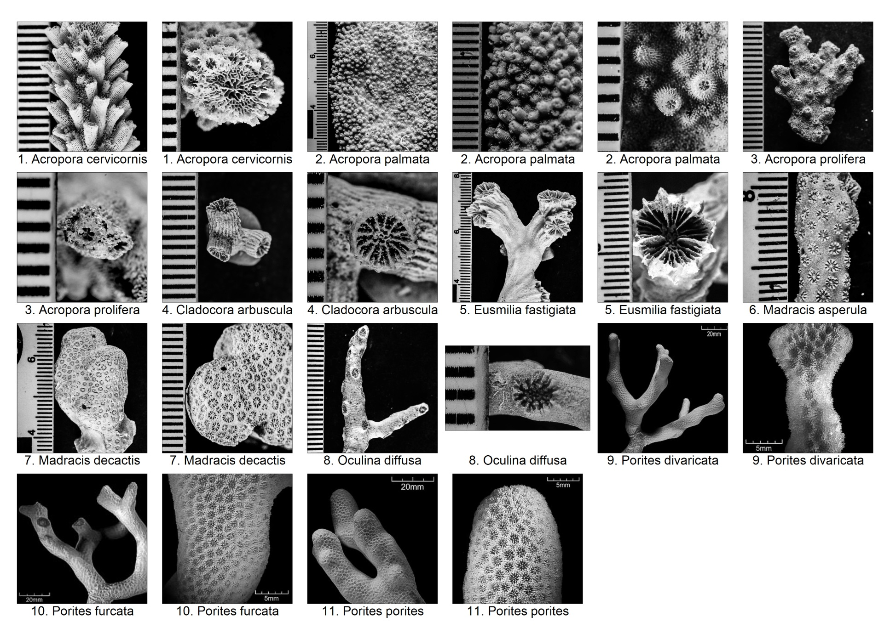

|  |  |  |  |  |  |  |  |  |  |  |  |  |  |  |
| --- | --- | --- | --- | --- | --- | --- | --- | --- | --- | --- | --- | --- | --- | --- |
|  | Species | Corallite Size (mm) | Coralite wall thickness | Columellae size (mm) | Septal Number | Septal Cycle | Septal Teeth | Columella | Costae | Coenosteum | Branch diameter (cm) | Colony Form | Similar species | Comments/Notes |
| 1 | *Acropora cervicornis* | 0.8-1 | - | - | 6 | 1 | - | Absent | - | 0.2-0.3mm | 1-3 | Plocoid | Acropora formosa (not in the Carribean/E. Pacific), Acropora prolifera | Corallite: Distinctive singular central axial corallites with tubular radial corallites; <5mm long |
| 2 | *Acropora palmata* | 0.5-0.8 | - | - | 6 | 1 | - | Absent | - | 0.1-0.2mm | 5-25 | Plocoid | Acropora prolifera | Corallite: No distinctive axial corallite; irregular length; tubular; <5mm long Branches: Singular branches Colony: Largest among Acropora |
| 3 | *Acropora prolifera* | 0.8-1.0 | - | - | 6 | 1 | - | Absent | - | 0.2-0.3mm | 0.5-2 | Plocoid | Acropora cervicornis, Acropora palmata | Corallites: Radial corallites orient upwards in rows; <5mm long Branches: Fuse at crossings Biology: Hybrid between A. cervicornis and A. palmata |
| 4 | *Cladocora arbuscula* | <6 | - | 1 | 36 | - | - | Trabecular; discontinuous | - | - | - | Phaceloid | - | Branches: Fine ridges running along the length; each ending with a single corallite |
| 5 | *Eusmilia fastigiata* | 80-130 | - | - | 15-18/cm | 2 | None | Trabecular; continuous | Well-developed | N/A | - | Phaceloid | - | Colony: Hemispherical mounds Septa: Widely spaced; primary septa exsert |
| 6 | *Madracis asperula* | 1 | - | - | 10 | 2 | - | Styliform (well-developed) | Absent | - | - | Plocoid | - | Biology: Primarily an azooxanthellae species Septa: Fuse with columella |
| 7 | *Madracis decactis* | 1.3-1.9 | - | - | 10 | - | - | Styliform (well-developed) | Absent | - | 2-3 | Plocoid | - | Colonies: Nodular (flattened and club-shaped), laminar or encrusting Coenosteum: Fine spicules (sometimes form ridge between corallites) Septa: Fuse with columella |
| 8 | *Oculina diffusa* | 1.5-5 | - | - | - | - | - | Trabecular (well-developed) | Absent/Reduced | - | <1.5 | Plocoid | Oculina varicosa | Corallites: Have neat round exsert walls Septa: Slight alternation of long and short |
| 9 | *Porites divaricata* | <1.6 | - | - | 12 | 1 | - | Trabecular (weak); discontinuous | - | - | <1 | Subplocoid | Porites furcata, Porites porites | Pali: 5-6 Branch: Often divide near tips |
| 10 | *Porites furcata* | 1.6-1.8 | - | - | 12 | 1 | - | Trabecular; discontinuous | - | - | 1-2 | Subplocoid | Porites divaricata, Porites porites | Branches: Thinner than P. porites but not as slender/branched as P. divaricata; tightly compacted Pali: 5-6 |
| 11 | *Porites porites* | 1.8-2.0 | - | - | 12 | 1 | - | Trabecular; discontinuous | - | - | >2 | Subplocoid | Porites divaricata, Porites furcata | Branches: Stout, irregular, and stubby with blunt and often enlarged tips Pali: 5-6 |

Massive Brains Corals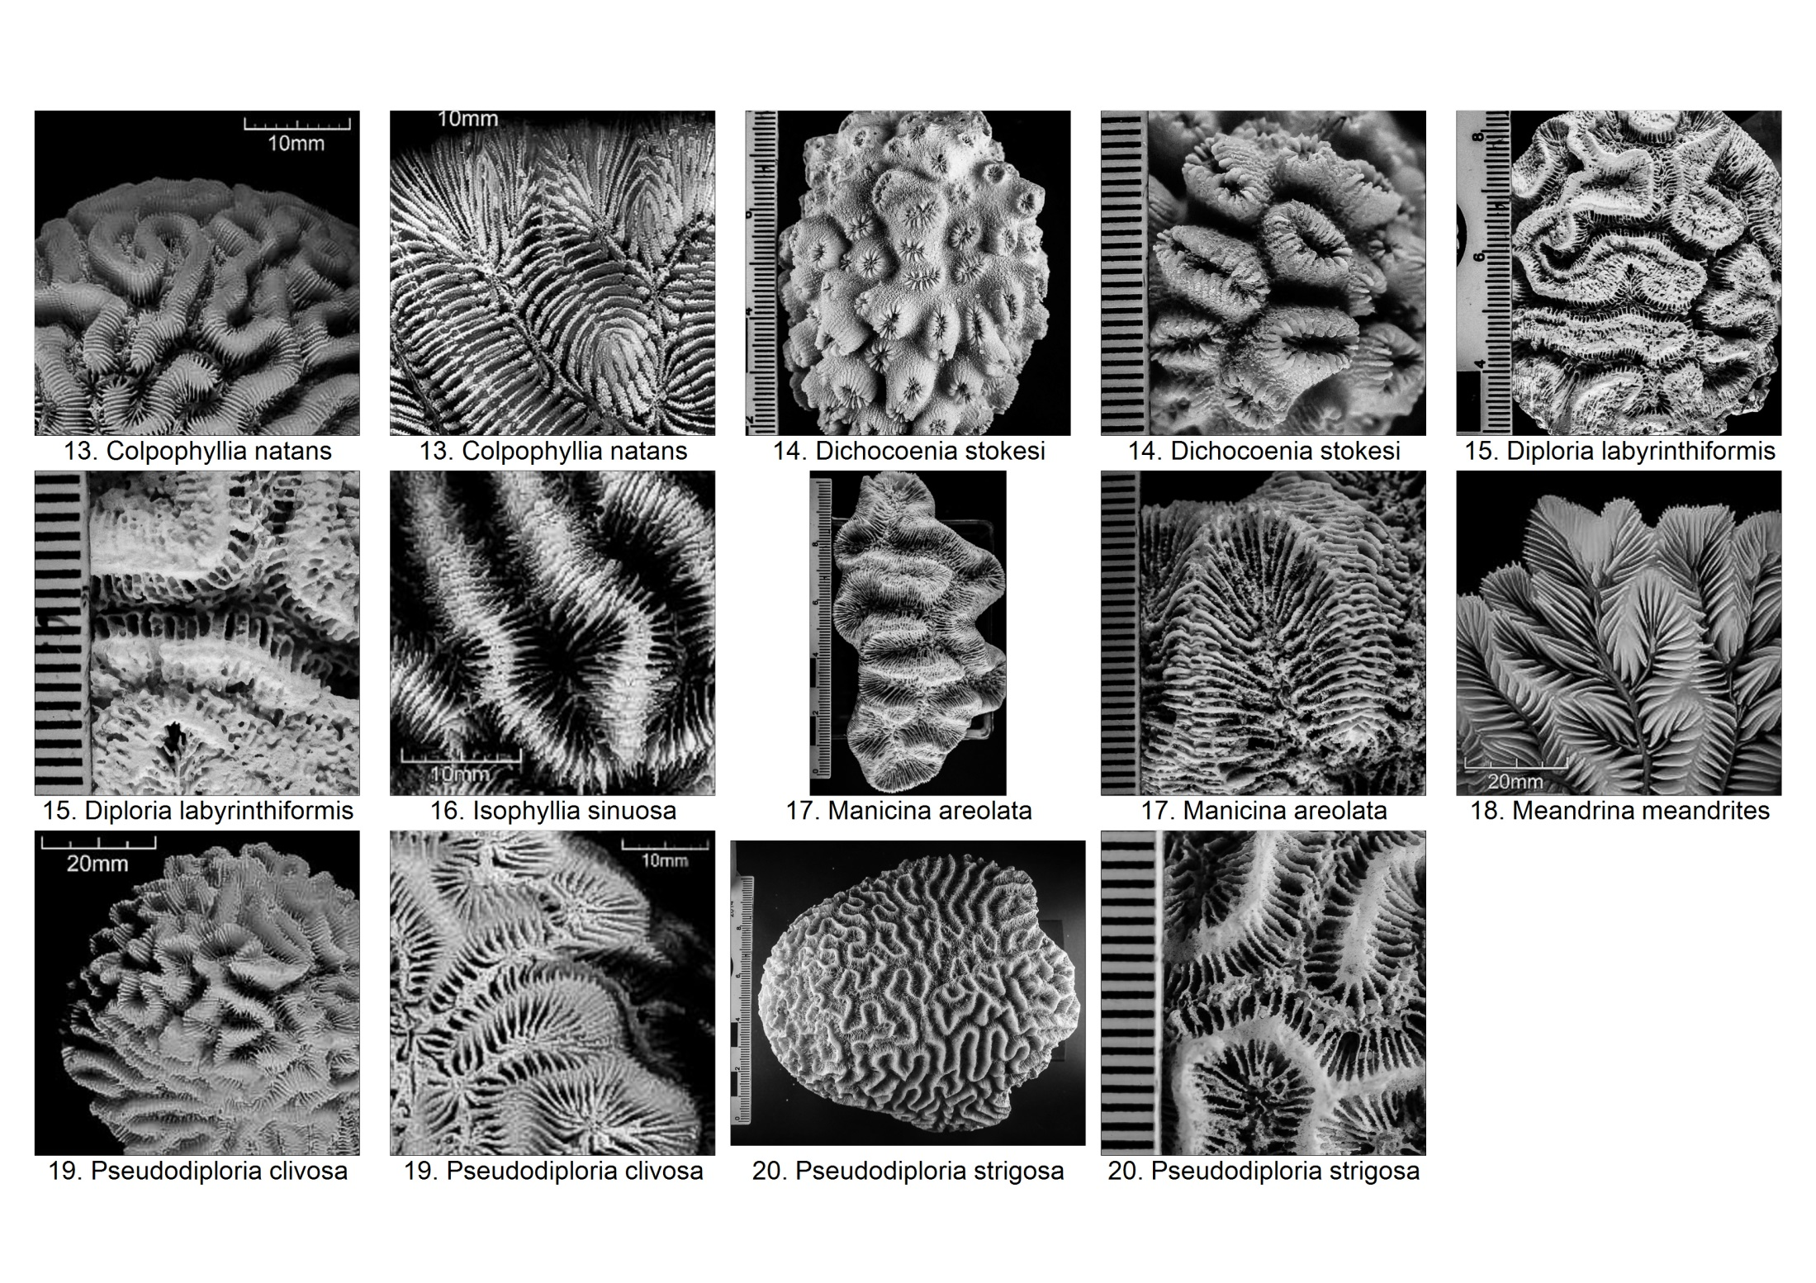

|  |  |  |  |  |  |  |  |  |  |  |  |  |  |  |
| --- | --- | --- | --- | --- | --- | --- | --- | --- | --- | --- | --- | --- | --- | --- |
|  | Species | Coralite wall thickness | Columellae size (mm) | Valley width (mm) | No. of Centers per Series | Septal Number | Septal Cycle | Septal Teeth | Columella | Costae | Coenosteum | Colony Form | Similar species | Comments/Notes |
| 13 | *Colpophyllia natans* | - | <1/4 of valley width | 10-15 | 1-3 | <12/cm | >3 | Small | Trabecular; discontinuous | Well-developed; discontinuous | Narrow (less than valley width) | Meandroid (sinous) | Colpophyllia breviserialis | Colony shape: Hemispherical or encrusting Septa: Exsert, equal Ambulacral groove: Fine; throughout top of wall |
| 14 | *Dichocoenia stokesii* | - | - | 3.5-4.5 | - | - | 2 | - | Trabecular (weak) | - | - | Plocoid/Ploco-meandroid | Dichocoenia stellaris | Colony shape: spherical/thick or submassive plates Corallites: Protrude, irregular, elliptal, circular or Y-shaped Taxonomy: Formerly known as Dichocoenia stellaris |
| 15 | *Diploria labyrinthiformis* | - | 1/2 of valley width | 5-10 | Not distinct | 12-24/cm | >3 | - | Trabecular (weak); continuous | Well-developed; discontinuous | Wide | Meandroid (sinuous or parallel) | Colpophyllia natans | Colony shape: May also be hemispherical Ambulacral groove: Vary greatly within colony; may be wider than valleys (give superficial appearance of alternating valleys) |
| 16 | *Isophyllia sinuosa* | - | - | 10-15 | 5-10 | >12/cm | >3 | - | Trabecular; discontinuous | - | - | Meandroid (sinuous) | - | Colony: Also oval to hemispherical domes Septa: Thin, large prominent teeth; continuous |
| 17 | *Manicina areolata* | - | 1/3 of valley width | 10-15 | - | 12-24/cm | >3 | - | Continuous | Discontinuous | Narrow | Meandroid | - | Colony: (Most common) Small elliptical colonies with one long, continuous central valley and several short side valleys (with cone-shaped underside); also as hemispherical heads with a flat underside. Taxonomy: One of its former synonyms is Manicina mayori |
| 18 | *Meandrina meandrites* | - | 10-20 | - | - | - | - | - | Lamellar | - | - | Meandroid | - | Colony: Hemispherical heads and flattened plates Ridges: Formed by smooth, widely separated septa; thin line along top where septa come together |
| 19 | *Pseudodiploria clivosa* | - | 1/2 of valley width | 4-10 | >5 | >24/cm | ~4 | - | Trabecular; continuous | Well-developed; discontinuous | Fused walls | Meandroid (sinuous) | - | Colony shape: May be encrusting Ridges: Rise sharply Ambulcral groove: Fine (if any) Taxonomy: Formerly known as Diploria clivosa |
| 20 | *Pseudodiploria strigosa* | - | 1/2 of valley width | 5-10 | - | 12-24/cm | >3 | - | Well-developed; continuous | Continuous | Fused walls | Meandroid (sinuous) | Platygyra daedalea | Colony shape: May also be encrusting Ridges: Evenly rounded, occasionally with extremely fine groove (usually without any) Taxonomy: Formerly known as Diploria strigosa |

## Massive Star Corals

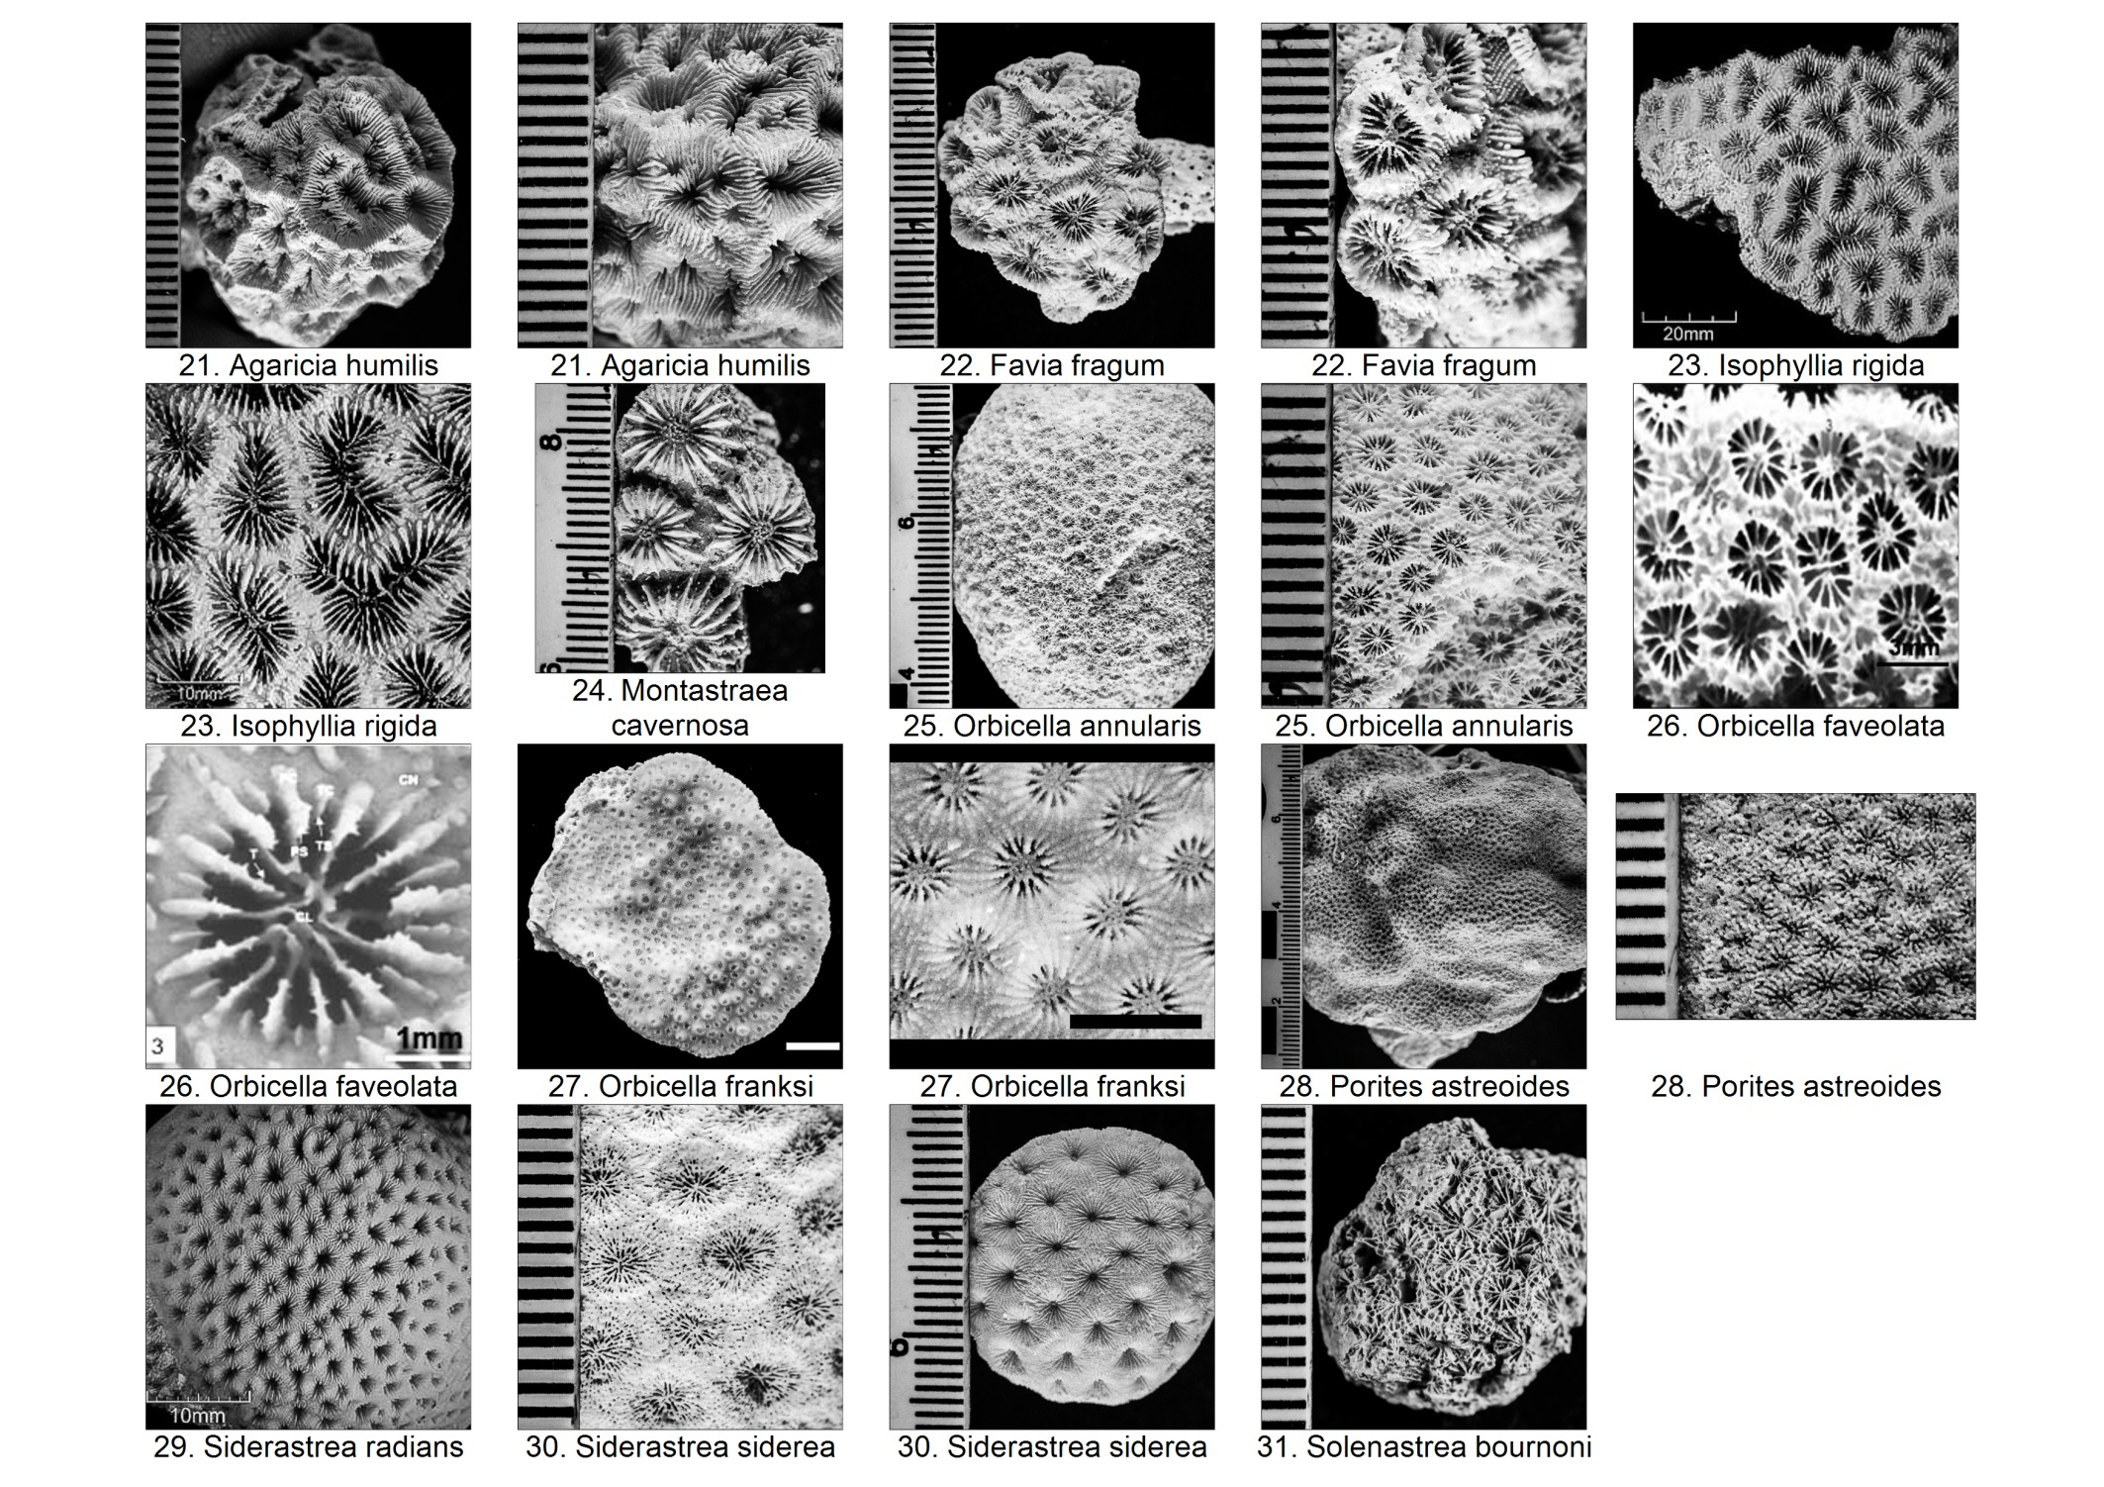

|  |  |  |  |  |  |  |  |  |  |  |  |  |  |  |  |
| --- | --- | --- | --- | --- | --- | --- | --- | --- | --- | --- | --- | --- | --- | --- | --- |
|  | Species | Corallite Size (mm) | Coralite wall thickness | Columellae size (mm) | Valley width (mm) | No. of Centers per Series | Septal Number | Septal Cycle | Septal Teeth | Columella | Costae | Coenosteum | Colony Form | Similar species | Comments/Notes |
| 21 | *Agaricia humilis* | - | - | - | - | - | - | - | - | - | - | - | - | Agaricia agaricites | - |
| 22 | *Favia fragum* | <5 | - | 1/2 of calice/valley width | N/A | 1-3 | 12-24/cm | ~4 | - | Trabecular (well-developed); continuous | Well-developed; discontinuous | Narrow | Plocoid | Dichocoenia | Corallite: <2mm high; oval with protruding rims (<2mm high) Colony size: Usually <5cm |
| 23 | *Isophyllia rigida* | 10-20 | - | - | 10-15 | 1-2 | - | - | - | Trabecular (weak); discontinuous | - | - | Cerioid | - | Septa: Thin, fine pointed teeth Taxonomy: Formerly known as Isophyllastrea rigida (Veron 2000) |
| 24 | *Montastraea cavernosa* | 5.5-7.5 | - | - | N/A | N/A | 36-48 | - | Channel shape, elliptical perpendicular bases | Trabecular | - | 5-9mm | Plocoid | - | Colony shape: May also be conical (sometimes taller than wide), plates or sheets |
| 25 | *Orbicella annularis* | 2.1-2.6 | Intermediate | 1.02 | N/A | N/A | 24 | 3 | Irregular, multidirectional with circular bases | Trabecular | - | 0.6-1.2mm | Plocoid | Favia stelligera (corallite: 2.5mm), Montastraea curta (corallite: 5mm), Montastraea salebrosa (all of which do not occur in Panama) | Colony shape: May also be columbar or flat Corallites: Flush to colony surface of conical; Septothecal walls Septa: Alternating long and short Taxonomy: Formerly known as Montastraea annularis |
| 26 | *Orbicella faveolata* | 2.2-2.7 | thin | 0.96 | N/A | N/A | 24 | 3 | Irregular, multidirectional with circular bases | - | - | - | Plocoid | - | Corallites: Very thin, partially parathecal walls formed by disspiments Taxonomy: Formerly known as Montastraea faveolata |
| 27 | *Orbicella franksii* | 2.4-3.4 | thick | 1.13 | N/A | N/A | 24 | 3 | Irregular, multidirectional with circular bases | - | - | - | Plocoid | - | Corallites: Septotecal walls Taxonomy: Formerly known as Montastraea franksii |
| 28 | *Porites astreoides* | 1.2-1.4 | - | - | N/A | N/A | 12 | 1 | - | Trabecular (well-developed) | - | - | Subplocoid | - | Colony shape: Encrusting>massive; lumpy>smooth/nodular Pali: >2 |
| 29 | *Siderastrea radians* | 2.5-3 | - | - | N/A | N/A | 30-40 | 3 | - | Trabecular | - | - | Cerioid | - | Colony shape: Sometimes as free-living mobile balls (<2.5cm) or small flat discs Corallite: Deep, usually irregular; angular |
| 30 | *Siderastrea siderea* | <5 | - | - | N/A | N/A | 50-60 | - | - | Trabecular | - | - | Cerioid | Siderastrea radians | Colony shape: May also be encrusting Septa: Tightly compacted  Corallites: Shallower and larger than Siderastrea radians |
| 31 | *Solenastrea bournoni* | 2-2.5 | - | - | N/A | N/A | - | - | - | Trabecular | - | - | Plocoid | Solenastrea hyades | Colony shape: May also be hemispherical fomes  Corallites: Protruding rims like blisters forming conspicuous dark circles |

## Thin Leafy Corals

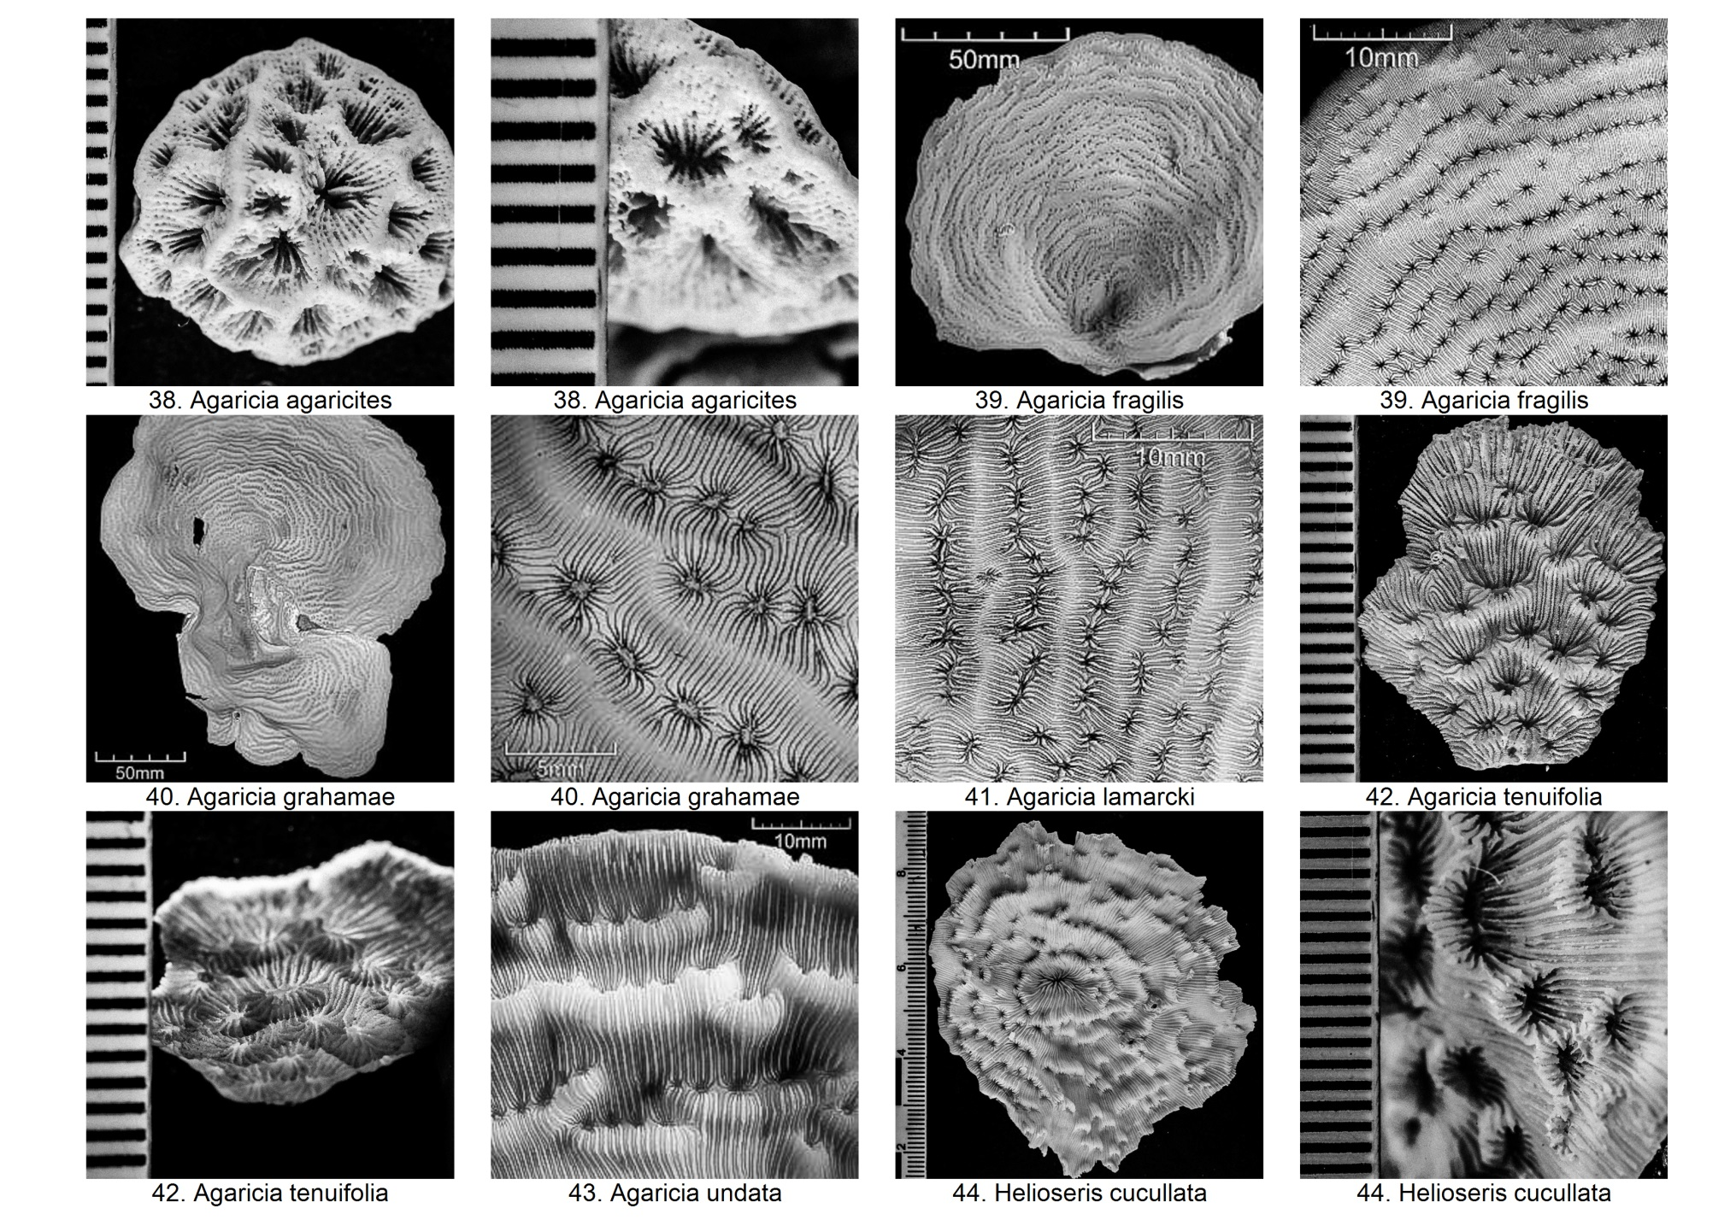

|  |  |  |  |  |  |  |  |  |  |  |  |  |  |  |  |  |
| --- | --- | --- | --- | --- | --- | --- | --- | --- | --- | --- | --- | --- | --- | --- | --- | --- |
|  | Species | Corallite Size (mm) | Coralite wall thickness | Columellae size (mm) | Valley width (mm) | No. of Centers per Series | Septal Number | Septal Cycle | Septal Teeth | Columella | Costae | Coenosteum | Surface | Colony Form | Similar species | Comments/Notes |
| 38 | *Agaricia agaricites* | 2-4 | - | - | - | - | <36 | - | - | Trabecular; discontinuous | - | - | - | Meandroid | Agaricia undata | Colony shape: May also be encrusting/thick leaves/irregular projections/flat plates Corallites: May be unifacial or bifacial Walls: Angular; pointed ridge tops |
| 39 | *Agaricia fragilis* | 1.9-2.5 | - | - | 2-4 | - | 17-36 | - | - | Trabecular (weak); discontinuous | - | - | Uneven concentric circles radiating from center | Meandroid | Agaricia grahamae, Agaricia undata | Corallites: Unifacial; small and close together; face upwards;  Colony: Nearly smooth underside |
| 40 | *Agaricia grahamae* | 2-2.9 | - | - | - | - | 18-28 | - | - | Trabecular (well-developed); discontinuous | - | - | - | Meandroid | Agaricia lamarcki, Agaricia fragilis | Colony shape: Flat; whorls; smooth underside Corallites: Unifacial; concentric rows of ridges with narrow, long and wavy valleys Septa: thick; do not alternate |
| 41 | *Agaricia lamarcki* | 3.1-4.1 | - | - | - | - | 20-32 | - | - | Trabecular; discontinuous | - | - | - | Meandroid | Agaricia grahamae | Colony shape: Flat; may be encrusting; whorls; smooth underside Corallites: Unifacial; concentric rows of ridges with wide, straight or reticulate valleys Septa: Alternate long (usually extend close to columella before dropping off sharply) and short (slope gradually into corallite pit) |
| 42 | *Agaricia tenuifolia* | - | - | - | - | - | - | - | - | - | - | - | - | Meandroid | - | Colony shape: Thin margins; contorted; elongate Corallites: Unifacial Taxonomy: Commonly assigned to genus *Undaria*. |
| 43 | *Agaricia undata* | 2-2.9 | - | - | 6-7 | - | 13-24 | - | - | Trabecular (well-developed); discontinuous | - | - | High rounded concentric ridges | Meandroid | Agaricia fragilis | Colony shape: Flat or upright; curve upward near edges; smooth underside Corallites: Unifacial; close together; occur on outward facing edge of walls (collines) Valleys: Straight, wide, wavy |
| 44 | *Helioseris cucullata* | <2.5 | - | - | - | - | 15-22 | - | - | Trabecular (weak/none); discontinuous | - | - | - | Meandroid | Leptoseris mycetoseroides (not in Panama) | Colony shape: May also be encrusting/tiered; 10-25cm Corallies: Closely compacted, outwardly incllined; concentric rows; short and discontinuous ridges and valleys Septa: Alternate long and short (strong) Taxonomy: Formerly known as Leptseris cucullata |

## Lumpy Corals

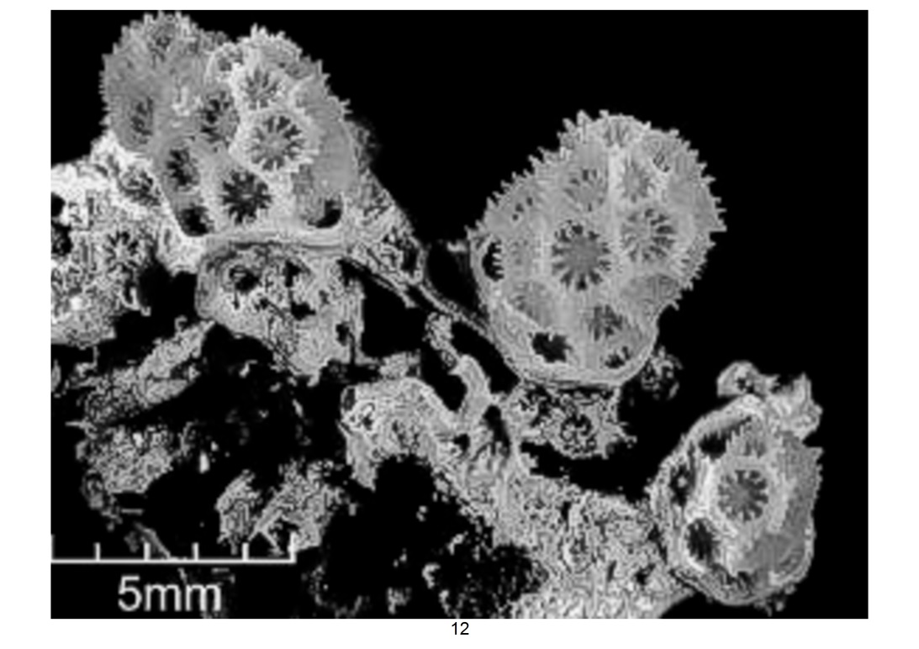

12. Madracis pharensis

|  |  |  |  |  |  |  |  |  |  |  |  |  |  |
| --- | --- | --- | --- | --- | --- | --- | --- | --- | --- | --- | --- | --- | --- |
|  | Species | Corallite Size (mm) | Coralite wall thickness | Columellae size (mm) | Septal Number | Septal Cycle | Septal Teeth | Columella | Costae | Coenosteum | Colony Form | Similar species | Comments/Notes |
| 12 | *Madracis pharensis* | ~1.5 | - | - | 10 | 2 | - | Styliform (well-developed) | - | - | Plocoid | - | Distribution: Mostly in the Dominican Republic (Corals of the World: None in Panama); Deep water Septa: Fuse with columella |

## Solitary Corals

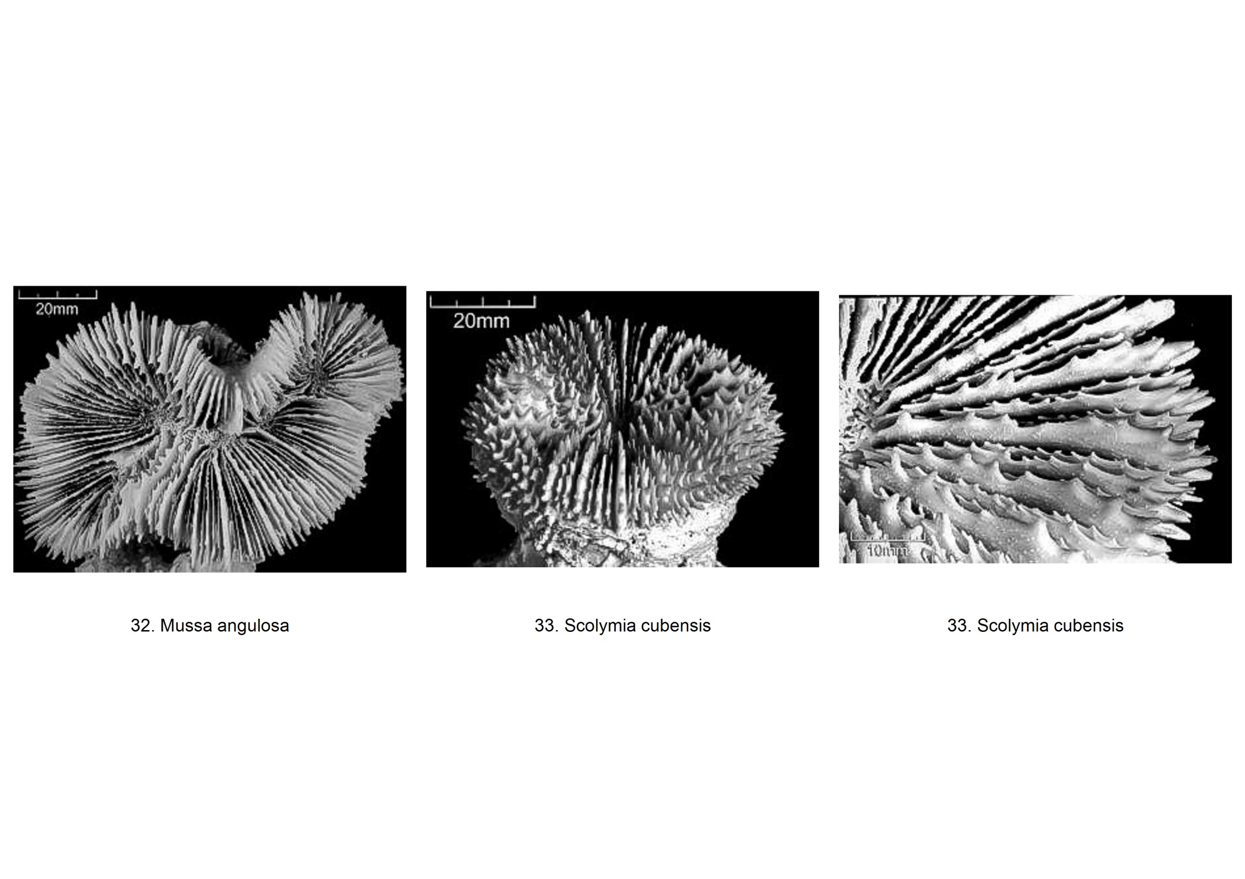

|  |  |  |  |  |  |  |  |  |  |  |  |  |  |  |
| --- | --- | --- | --- | --- | --- | --- | --- | --- | --- | --- | --- | --- | --- | --- |
|  | Species | Corallite Size (mm) | Coralite wall thickness | Columellae size (mm) | Valley width (mm) | No. of Centers per Series | Septal Number | Septal Cycle | Septal Teeth | Columella | Costae | Colony Form | Similar species | Comments/Notes |
| 32 | *Mussa angulosa* | 45-70 | - | - | - | <5 (in flabellomeandroid) | 6-9/cm | >4 | - | Trabecular (well-developed); discontinuous | - | Phaceloid-Flabellomeandroid | Scolymia cubensis | Colony shape: May also be flat or hemispherical; branching>solitary Septa: Prominent tall sharp teeth; septal granules grow in more than one plane |
| 33 | *Scolymia cubensis* | <100 | - | - | N/A | - | 80 | >5 | - | Trabecular; discontinuous | Well-developed | Solitary | Mussa angulosa; Scolymia lacera (positive ID requires magnified examination of septa) | Colony shape: Usually attached but may be free-living; tapered base; circular to oval Septa: Septal granules grow in a single plane Corallite: Center usually flat to convex, rarely concave |

## Thick Leafy Corals

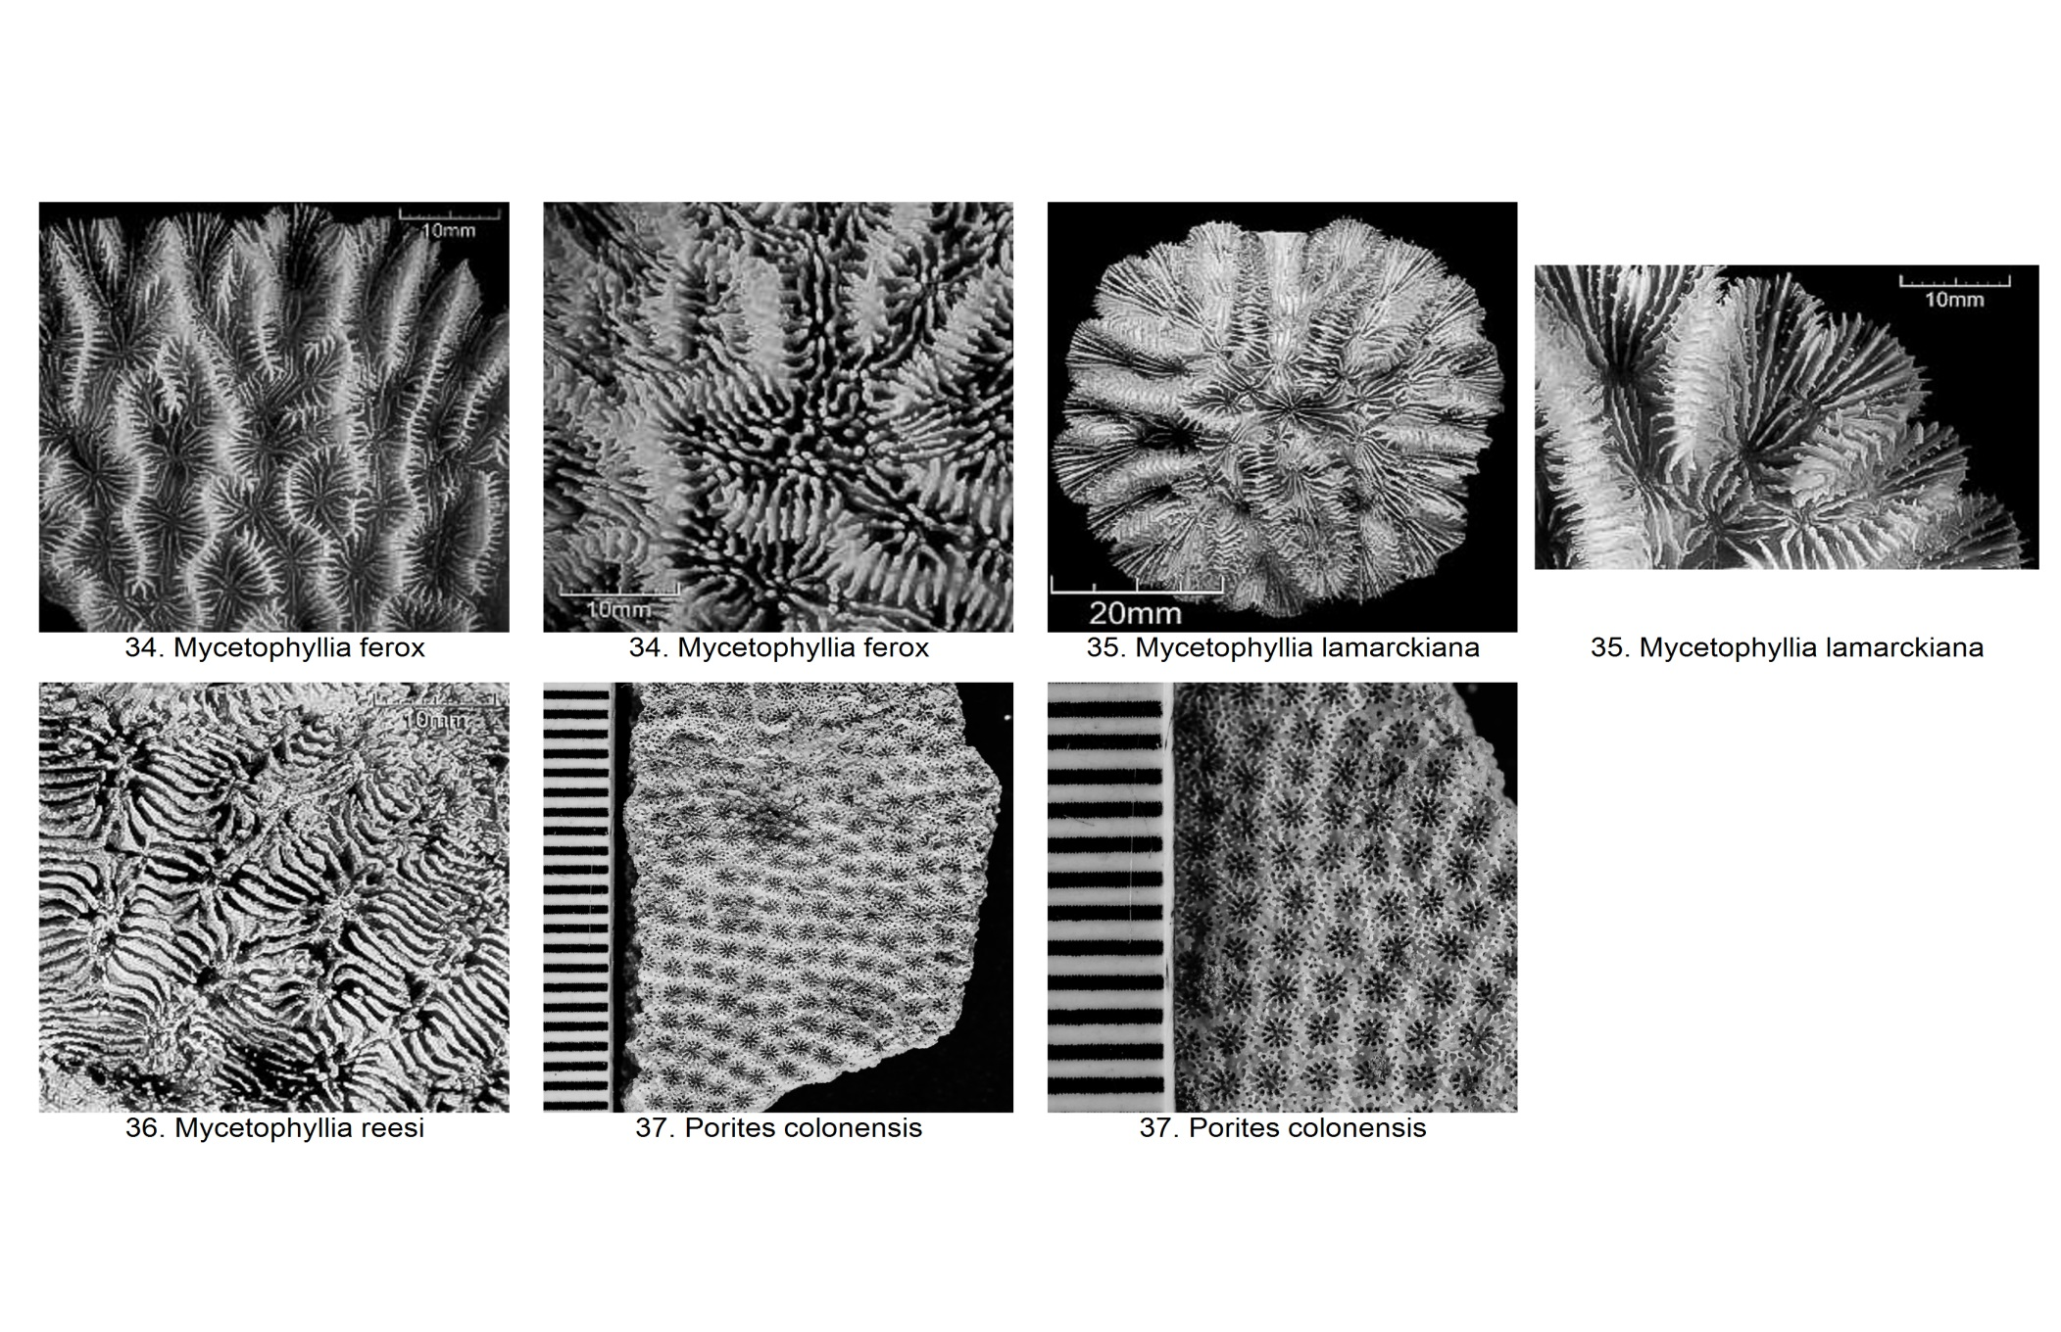

|  |  |  |  |  |  |  |  |  |  |  |  |  |  |  |  |
| --- | --- | --- | --- | --- | --- | --- | --- | --- | --- | --- | --- | --- | --- | --- | --- |
|  | Species | Corallite Size (mm) | Coralite wall thickness | Columellae size (mm) | Valley width (mm) | No. of Centers per Series | Septal Number | Septal Cycle | Septal Teeth | Columella | Costae | Coenosteum | Colony Form | Similar species | Comments/Notes |
| 34 | *Mycetophyllia ferox* | - | - | - | 10-15 | - | - | - | - | Trabecular (weak/absent); continuous | - | - | Meandroid | - | Colony shape: Thin; weakly attached Corallites: Centres in single rows Valleys: Slightly sinuous |
| 35 | *Mycetophyllia lamarckiana* | - | - | - | 10-15 | - | - | - | - | Trabecular (weak/absent); continuous | - | - | Meandroid | - | Colony shape: Solid, rounded, often circular plates Valleys: Radiate from original point of growth; one row of mouths Corallite: Vaguely concentric to plate margins |
| 36 | *Mycetophyllia reesi* | - | - | - | 10-15 | - | - | - | - | Trabecular (weak/absent); continuous | - | - | Meandroid | Mycetophyllia lamarckiana | Colony shape: Thin laminae (sometimes conforming to substrate shape); attached centrally/at the side Valley: Do not radiate Corallite: Centers parallel to plate margins |
| 37 | *Porites colonensis* | 1.8-2 | - | N/A | N/A | N/A | 12 | 1 | - | Absent | - | - | Subplocoid | - | Colony shape: Thin; sometimes in tiers; smooth or undulating surface Pali: 5-6 |

# Glossary of Coral Morphology

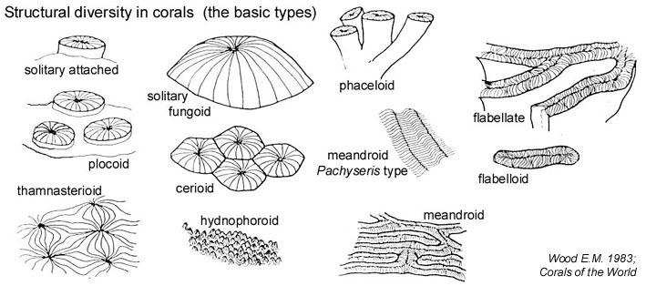

**Corallite wall**

**Septa**

**Paliform lobe**

**Septa-costae**

Figure 2: Different structures of a corallite

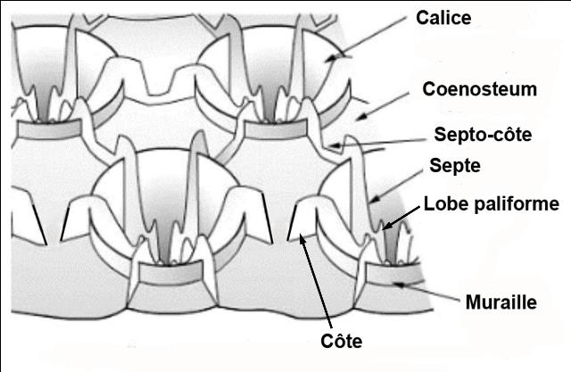

Figure 1: A sample of the various coral shapes

**Costae**

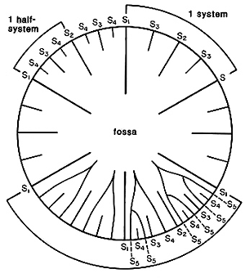

Figure 3:Septal cycle – upper right system with three cycles of septa; upper left system with four cycles, and lower two systems with various stages of development of the Poutralès plan Numbers refer to cycle to which septa belong. (Cairns 1994)

|  |  |
| --- | --- |
| Coral Morphology | Definitions |
| Calice | Cup-shaped depression on corallite surface |
| Centers per Series | Number of corallites in a series/valley |
| Coenosteum | Skeleton between corallites within a colony |
| Columella | Central axial structure within a corallite |
| Columella (Lamellar) | Plate-like, parallel to valley |
| Columella (Papillose) | Many small rods |
| Columella (Solid) | Central |
| Columella (Trabecular) | Formed by inner ends of septa |
| Coral Form | Overall shape of colony |
| Coral Form (Branching) | Flattened with calices on only one side |
| Coral Form (Massive) | Elongated projections |
| Coral Form (Platy) | Mound-shaped/Encrusting |
| Coral Shape | Corallite arrangement |
| Coral Shape (Cerioid) | Cerioid: Juxtaposed and even, with own walls (those of massive corals share common walls) |
| Coral Shape (Dendroid) | Dendroid: Branch from each other in dendritic pattern |
| Coral Shape (Fasciculate) | Fasciculate: Cylindrical but not in contact; may be dendroid (irregular branches) or phaceloid |
| Coral Shape (Flabelloid) | Flabelloid: Arranged in single series; adjacent valleys do not share ridges |
| Coral Shape (Flabello-meandroid a. k. a flabellate) | Flabello-meandroid a.k.a flabellate: Long meandering rows with common base; walls may be partially fused |
| Coral Shape (Hydnophoroid) | Hydnophoroid: Cone-shaped protuberances between corallites |
| Coral Shape (Meandroid) | Meandroid: Arranged in multiple series; adjacent valleys share ridges |
| Coral Shape (Phaceloid) | Phaceloid: Separated by voided space; those with distinct walls separated by coenosteum |
| Coral Shape (Plocoid) | Plocoid: Short-stalked and isolated, separated by coenosteum |
| Coral Shape (Solitary) | Solitary: Entire coral = one corallite |
| Coral Shape (Subplocoid) | Subplocoid: Sometimes separated by coenosteum, each with its own wall |
| Coral Shape (Thamnasterioid) | Thamnasterioid: Confluent septa of adjacent corallites, often twisted or sinuous |
| Corallite | Skeleton of solitary individual or an individual within a colony |
| Costae | Extension of septum beyond wall |
| Paliform lobes | Exsert protuberance of septum at center of corallite |
| Septa | Radially-arranged vertically partitions within a corallite (exsert, insert or even in regard to corallite wall) |
| Septa-costae | Structure that flows between corallites when corallite walls are indistinct |
| Septal cycle | No. of types of septa with difference lengths and thickness |
| Septal granules | Small elevation on septa or septa teeth |
| Septal spacing | Spacing between septa/No. of septa per unit distance |
| Septal teeth | Sharp projections lining the upper margins of septa |
| Synapticulum | Conical or cylindrical supporting process extending between septa |
| Valley | A series of corallites |
| Wall | Vertical structure enclosing corallite |

# References and Additional Resources

### Coral Taxonomy

* http://www.marinespecies.org/index.php

### Coral Species ID

* http://coral.aims.gov.au/info/factsheets.jsp
* http://eusmilia.geology.uiowa.edu/nmita/generaList.page?classification=NMITA&taxonName=Zooxanthellate+Coral&getGenButton=Get+Genera
* http://coralpedia.bio.warwick.ac.uk/
* https://www.stri.si.edu/english/PDFs/201215_Hard_Coral_Identification_guide.pdf
* http://eusmilia.geology.uiowa.edu/idstep1.htm
* http://species-identification.org/index.php
* Budd, Ann F., and Jarosław Stolarski. "Searching for New Morphological Characters in the Systematics of Scleractinian Reef Corals: Comparison of Septal Teeth and Granules between Atlantic and Pacific Mussidae." Acta Zoologica 90.2 (2009): 142-65. Web. 23 June 2016.
* http://digital.lib.uiowa.edu/cdm/search/collection/coral

### Glossary of Coral Morphology

* http://biophysics.sbg.ac.at/png/png3.htm
* http://eusmilia.geology.uiowa.edu/database/corals/glossary/glossmnu.htm
* http://www.coralhub.info/terms/corallite/
* http://tolweb.org/Dendrophylliidae/19165
* http://www.cap-recifal.com/page/articles.html/_/vivant/identification-des-scl%C3%A9ractiniaires-r44